**Retail Analysis Documentation**

**Project Overview**

Welcome to the Retail Analysis Documentation. In this document, we will outline the key components of our analysis, which include Sales Analysis, Product Analysis, Customer Analysis, Payment Analysis, and Order Analysis. This comprehensive examination of our retail business aims to provide valuable insights, inform decision-making, and enhance our overall performance.

**Objectives**  
  
Sales Analysis:

To understand the performance of our sales activities.

In Sales Analysis, we will:

Examine sales trends and patterns.

Analyse sales by product categories, regions, and time periods.

Identify top-selling products and their impact on revenue.

Assess the effectiveness of sales channels, such as physical stores and e-commerce platforms.

Product Analysis:

To gain insights into our product inventory.

In Product Analysis, we will:

Evaluate the popularity of different product categories.

Analyse product performance, including best-sellers and slow-moving items.

Examine pricing strategies and their impact on product sales.

Identify opportunities for product diversification or optimization.

Customer Analysis:

To understand our customer base and their preferences.

In Customer Analysis, we will:

Segment customers based on demographic factors such as age, gender, income, and location.

Analyse customer buying behaviour and preferences.

Assess customer loyalty and lifetime value.

Tailor marketing and sales strategies to specific customer segments.

Payment Analysis:

To examine payment methods and their impact on sales.

In Payment Analysis, we will:

Investigate payment methods preferred by customers.

Analyse payment trends and their correlation with sales volume.

Identify any issues related to payment processing or customer experience.

Optimize payment options to enhance customer satisfaction and sales.

Order Analysis:

To evaluate the order fulfilment process.

In Order Analysis, we will:

Assess order processing times and efficiency.

Analyse order accuracy and potential issues.

Examine returns and order cancellations.

Identify opportunities to streamline the order fulfilment process.

**Significance of This Project**

* Customer Understanding:

This project offers valuable insights into customer behaviour, preferences, and demographic characteristics.

* Product Optimization:

By leveraging sales data and customer feedback, product selection can be fine-tuned for improved performance.

* Inventory Management:

Efficient inventory management, with a focus on reducing carrying costs and preventing stockouts, is a key outcome of this project.

* Competitive Positioning:

The project aids in distinguishing the business from competitors, thereby strengthening its competitive positioning.

* Pricing Strategies:

Optimal pricing strategies can be determined to enhance profitability and competitiveness.

* Targeted Marketing:

Data-driven insights from this project facilitate the development of precise marketing campaigns and promotions based on customer data.

* Operational Efficiency:

This initiative contributes to cost savings and streamlining operational efficiency.

* Adaptation to Trends:

The project keeps the business current with evolving market trends and shifting customer demands.

* Customer Satisfaction:

Improvements in the shopping experience, increased customer loyalty, and enhanced repeat business are anticipated outcomes.

* Sustainability and Growth:

The insights obtained through this project lay the foundation for long-term growth and sustainability within the retail industry.

**Project Process Documentation**

**Process Overview**

This document offers a thorough overview of the processes entailed in our project, which centres on the analysis of retail data. These processes include data acquisition, transformation, tool integration, problem statement resolution, exploratory data analysis, generation of visual content, and comprehensive documentation.

1. Data Acquisition from GitHub

Objective: Acquire the specified dataset from a dedicated GitHub repository, encompassing vital information pertaining to university rankings across multiple countries and ranking systems.

Action: Commence the analysis by downloading the dataset directly from the GitHub repository as per the project requirements.

2. Data Transformation and Enhancement

Objective: Guarantee data quality and consistency through meticulous data transformation and enrichment processes.

Action: Execute necessary data transformation procedures to improve data quality. Additionally, explore opportunities to enrich the dataset by introducing new problem statements that can enhance the analysis potential.

3. Connecting with Tools

Objective: Forge robust connections between the dataset and analytical tools to ensure seamless data integration and processing.

Action: Establish interfaces between the dataset and essential tools such as Power BI, Excel, and MySQL Workbench, enabling efficient data integration.

4. Problem Statement Solution in Power BI

Objective: Harness the capabilities of Power BI to tackle defined problem statements effectively.

Action: Utilize Power BI's powerful features for data visualization, exploration, and analysis, ultimately deriving valuable insights and innovative solutions.

5. Exploratory Data Analysis

Objective: Conduct in-depth exploratory data analysis.

Action: Employ either Excel or SQL Workbench, choosing the appropriate tool based on analysis complexity, to extract significant patterns, relationships, and trends from the data. These insights are invaluable for informed decision-making.

6. Creation of Visual and Insightful PowerPoint

Objective: Craft a comprehensive PowerPoint presentation that encapsulates the project's objective, methodology, problem statements, solutions, and key visualizations.

Action: Develop a PowerPoint presentation that includes dedicated sections for each problem statement, accompanied by relevant conclusions and insightful content.

7. Detailed Documentation

Objective: Thoroughly document every aspect of the project's lifecycle.

Action: Compile an extensive report encompassing data collection, transformation, problem statement formulation, tool integration, Power BI solutions, valuable insights, and content from the PowerPoint presentation.

This process document serves as a guide for the various phases of our project, ensuring a structured approach and successful completion.

**Data Dictionary**

TABLE 1 - CUSTOMERS

Customer Number (**PRIMARY KEY**):

Description: A unique identifier for each customer.

Customer Name:

Description: The name of the customer or the company.

Contact Last Name:

Description: The last name of the contact person.

Contact FirstName:

Description: The first name of the contact person.

Phone:

Description: The phone number for contacting the customer.

AddressLine1:

Description: The first line of the customer's address.

AddressLine2:

Description: The second line of the customer's address (if applicable).

City:

Description: The city where the customer is located.

State:

Description: The state or region where the customer is located.

Postal Code:

Description: The postal code or ZIP code for the customer's location.

Country:

Description: The country where the customer is located.

Sales Rep Employee Number:

Description: The employee number of the sales representative assigned to this customer.

Credit Limit:

Description: The credit limit or credit line assigned to the customer, indicating the maximum amount of credit the customer can have.

TABLE 2 - EMPLOYEES

Employee Number (**PRIMARY KEY**):

Description: A unique identifier for each employee.

Last Name:

Description: The last name of the employee.

First Name:

Description: The first name of the employee.

Extension:

Description: The phone extension for the employee.

Email:

Description: The email address of the employee.

Office Code:

Description: The code or identifier for the office where the employee works.

Reports To:

Description: A reference to the employee to whom this employee reports, usually represented by their employee Number.

Job Title:

Description: The job title or position held by the employee

TABLE 3 - OFFICE

Office Code (**PRIMARY KEY**):

Description: A unique identifier or code for each office.

City:

Description: The city where the office is located.

Phone:

Description: The phone number for contacting the office.

AddressLine1:

Description: The first line of the office's address.

AddressLine2:

Description: The second line of the office's address (if applicable).

State:

Description: The state or region where the office is located.

Country:

Description: The country where the office is located.

Postal Code:

Description: The postal code or ZIP code for the office's location.

Territory:

Description: The territory or region served by the office.

TABLE 4 - ORDER DETAILS

Order Number (**PRIMARY KEY**):

Description: A unique identifier for each order.

Product Code (**FOREIGN KEY**):

Description: A reference to the product associated with the order. This column typically relates to a "Products" table.

Quantity Ordered:

Description: The quantity of the product ordered in this specific line item.

Price Each:

Description: The price of each unit of the product in this line item.

Order Line Number:

Description: A sequential line number representing the order line item.

TABLE 5 - ORDERS

Order Number (**PRIMARY KEY**):

Description: A unique identifier for each order.

Order Date:

Description: The date when the order was placed.

Required Date:

Description: The date by which the order is required.

Shipped Date:

Description: The date when the order was shipped.

Status:

Description: The status of the order (e.g., "Shipped," "In Progress," "Cancelled," etc.).

Comments:

Description: Any additional comments or notes related to the order.

Customer Number (**FOREIGN KEY**):

Description: A reference to the customer who placed the order. This column typically relates to a "Customers" 54520. table

TABLE 6 - PAYMENTS

Customer Number (**FOREIGN KEY**):

Description: A reference to the customer making the payment. This column typically relates to a "Customers" table.

Check Number:

Description: The check number or payment reference for the transaction.

Payment Date:

Description: The date when the payment was made.

Amount:

Description: The amount of the payment.

TABLE 7 - PRODUCTS

Product Line:

Description: The product line or category to which the product belongs.

Product Scale:

Description: The scale or size of the product (e.g., 1:18, 1:24).

Product Vendor:

Description: The vendor or manufacturer of the product.

Product Description:

Description: A description or details about the product.

Quantity In Stock:

Description: The quantity of this product currently in stock or inventory.

Buy Price:

Description: The price at which the product is purchased.

MSRP (Manufacturer's Suggested Retail Price):

Description: The suggested retail price of the product

**ER DIAGRAM**

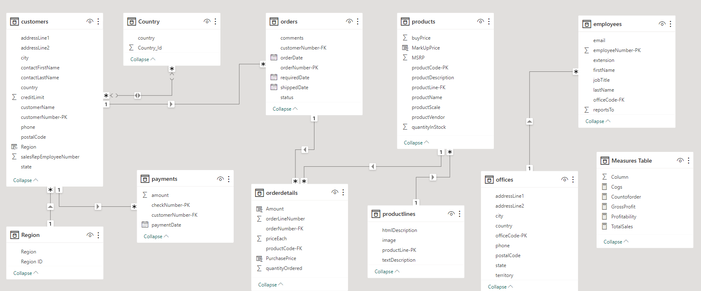

Which factors contribute to the highest sales in a particular region?

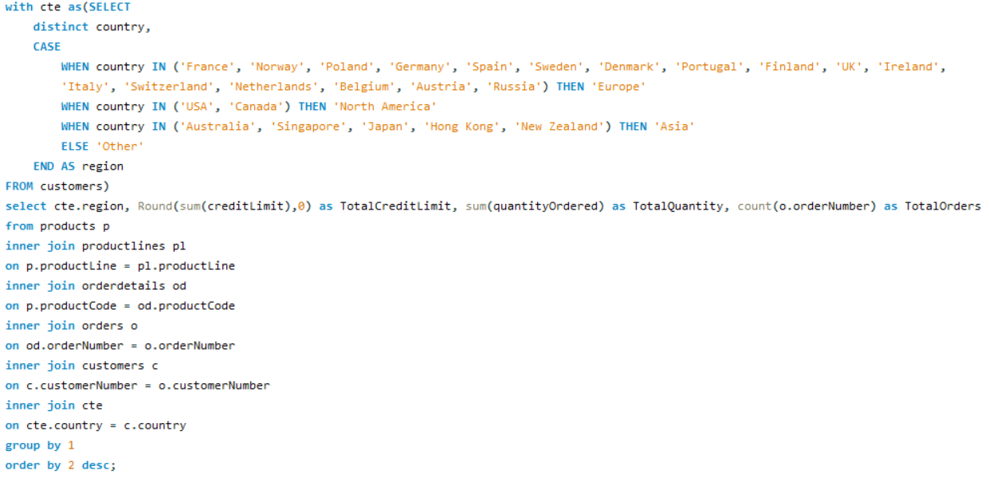

|  |  |
| --- | --- |
| Region | Sales |
| Europe | 4520712 |
| North America | 3479192 |
| Asia | 1516818 |
| Other | 87468 |

|  |  |  |  |
| --- | --- | --- | --- |
| Region | Credit Limit | Quantity Ordered | Total Orders |
| Europe | 16,62,75,200 | 49578 | 1415 |
| North America | 11,42,58,600 | 38137 | 1074 |
| Asia | 4,52,98,600 | 16840 | 481 |
| Other | 21,19,000 | 961 | 26 |

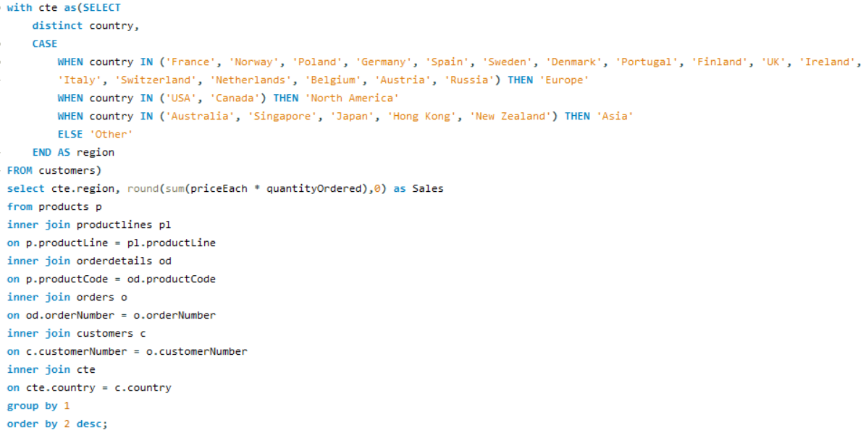

**Insight:   
  
Europe has the highest sales among all regions and it has maximum credit limit and number of orders is also highest in the Europe Region  
  
Reasons for Highest Sales:  
High Consumption of goods and High Credit Limit Offered**

How can customer purchasing patterns be influenced to increase average order value?

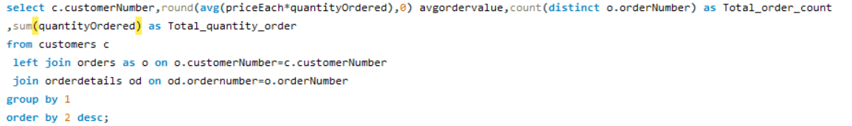

|  |  |  |  |
| --- | --- | --- | --- |
| CustomerNumber | Avg_Order_Value | Total_order_count | Total_quantity_order |
| 455 | 4140 | 2 | 636 |
| 209 | 3993 | 3 | 779 |
| 328 | 3896 | 3 | 988 |
| 175 | 3817 | 3 | 903 |
| 172 | 3763 | 3 | 836 |
| 151 | 3707 | 4 | 1775 |
| 204 | 3705 | 2 | 572 |
| 333 | 3679 | 3 | 545 |
| 201 | 3676 | 3 | 1046 |
| 381 | 3652 | 4 | 278 |
| 495 | 3641 | 2 | 695 |
| 148 | 3634 | 5 | 1524 |
| 357 | 3632 | 3 | 1003 |
| 344 | 3596 | 2 | 468 |
| 450 | 3588 | 4 | 1656 |
| 145 | 3586 | 5 | 1315 |
| 458 | 3514 | 3 | 1163 |
| 144 | 3510 | 4 | 647 |
| 298 | 3509 | 2 | 1078 |
| 334 | 3463 | 3 | 1031 |
| 424 | 3461 | 3 | 720 |
| 128 | 3452 | 4 | 811 |
| 382 | 3437 | 4 | 1442 |
| 259 | 3432 | 2 | 936 |
| 363 | 3425 | 3 | 1248 |
| 462 | 3409 | 3 | 903 |
| 452 | 3404 | 3 | 532 |
| 484 | 3399 | 2 | 589 |
| 250 | 3383 | 3 | 684 |
| 486 | 3379 | 3 | 730 |
| 157 | 3366 | 4 | 1111 |
| 475 | 3365 | 2 | 511 |
| 167 | 3364 | 3 | 973 |
| 385 | 3364 | 3 | 961 |
| 323 | 3361 | 5 | 1691 |
| 286 | 3354 | 2 | 976 |
| 227 | 3330 | 2 | 882 |
| 398 | 3298 | 4 | 1150 |
| 124 | 3288 | 17 | 6366 |
| 114 | 3283 | 5 | 1926 |
| 256 | 3271 | 2 | 637 |
| 121 | 3257 | 4 | 1082 |
| 362 | 3244 | 3 | 1036 |
| 321 | 3228 | 4 | 1447 |
| 386 | 3218 | 3 | 1280 |
| 239 | 3215 | 2 | 954 |
| 406 | 3201 | 3 | 1001 |
| 103 | 3188 | 3 | 270 |
| 202 | 3187 | 2 | 703 |
| 186 | 3185 | 3 | 1051 |
| 448 | 3183 | 3 | 1359 |
| 146 | 3178 | 3 | 1428 |
| 129 | 3177 | 3 | 692 |
| 473 | 3170 | 2 | 272 |
| 141 | 3169 | 26 | 9327 |
| 249 | 3162 | 2 | 843 |
| 233 | 3135 | 3 | 717 |
| 205 | 3127 | 3 | 1060 |
| 189 | 3119 | 2 | 490 |
| 177 | 3118 | 2 | 692 |
| 412 | 3115 | 3 | 1055 |
| 324 | 3098 | 3 | 937 |
| 353 | 3097 | 5 | 1433 |
| 171 | 3089 | 2 | 699 |
| 161 | 3075 | 4 | 1179 |
| 379 | 3064 | 3 | 795 |
| 131 | 3043 | 4 | 1631 |
| 242 | 3024 | 3 | 687 |
| 319 | 3017 | 2 | 929 |
| 166 | 2993 | 4 | 1236 |
| 119 | 2992 | 4 | 1832 |
| 311 | 2991 | 3 | 1110 |
| 276 | 2979 | 4 | 1469 |
| 216 | 2979 | 3 | 882 |
| 347 | 2965 | 2 | 500 |
| 173 | 2927 | 2 | 357 |
| 456 | 2923 | 2 | 381 |
| 282 | 2911 | 4 | 1601 |
| 320 | 2911 | 3 | 1140 |
| 187 | 2910 | 3 | 1778 |
| 181 | 2900 | 3 | 787 |
| 299 | 2877 | 2 | 787 |
| 496 | 2864 | 4 | 1647 |
| 350 | 2862 | 3 | 804 |
| 211 | 2843 | 2 | 596 |
| 487 | 2838 | 2 | 514 |
| 314 | 2834 | 3 | 796 |
| 112 | 2765 | 3 | 929 |
| 240 | 2761 | 2 | 895 |
| 339 | 2759 | 2 | 668 |
| 198 | 2694 | 3 | 287 |
| 278 | 2657 | 3 | 1650 |
| 219 | 2640 | 2 | 102 |
| 447 | 2630 | 3 | 666 |
| 260 | 2570 | 2 | 873 |
| 489 | 2466 | 2 | 357 |
| 471 | 2429 | 3 | 705 |
| 415 | 2236 | 1 | 401 |

**Insights:**  
  
By analysing the data, we have concluded the high-value customers and their buying habits. This insight guides targeted marketing and sales tactics, such as exclusive promotions, product bundles, and personalized suggestions, to boost their spending and raise the average order value.

What are the key drivers of sales growth, and how can they be leveraged for future success?

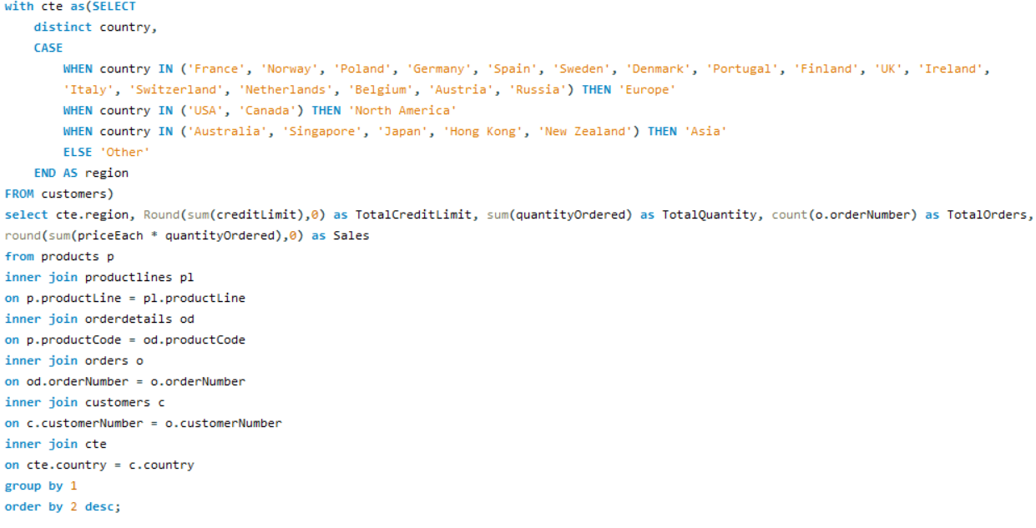

|  |  |  |  |  |
| --- | --- | --- | --- | --- |
| Region | TotalCreditLimit | TotalQuantity | TotalOrders | Sales |
| Europe | 16,62,75,200 | 49578 | 1415 | 45,20,712 |
| North America | 11,42,58,600 | 38137 | 1074 | 34,79,192 |
| Asia | 4,52,98,600 | 16840 | 481 | 15,16,818 |
| Other | 21,19,000 | 961 | 26 | 87,468 |

**Key drivers of sales growth include:**

* Total Credit Limit
* Total Quantity Sold
* Order Frequency
* Total Revenue Generated

Which product features or attributes are most appealing to customers?

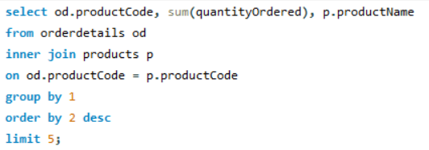

**Note:** Taken top 5 orders  
  
**Insights**: S18_3232 (**1992 Ferrari 360 Spider red)** has the most order   
So this attributes is most appealing to customers

**Product Feature of 1992 Ferrari 360 Spider red**His replica features opening doors, superb detail and craftsmanship, working steering system, opening forward compartment, opening rear trunk with removable spare, 4 wheel independent spring suspension as well as factory baked enamel finish.

How can the product mix be optimized to cater to changing market demands?

Optimizing the product mix to cater to changing market demands is a critical process that requires a combination of

* Market Research and Analysis
* Establish Clear Objectives
* Marketing and Promotion
* Pricing Strategy
* Supply Chain Optimization
* Product Development and Innovation

**Optimizing the product mix to adapt to evolving market demands is a vital initiative that demands a comprehensive strategy, encompassing:**

1. **Market Research and Analysis:** In-depth examination of market dynamics, customer preferences, and emerging trends to inform product selection.
2. **Establishing Clear Objectives:** Setting specific and measurable goals for product optimization, ensuring alignment with overall business objectives.
3. **Marketing and Promotion:** Crafting effective marketing strategies and promotional campaigns to drive product visibility and consumer engagement.
4. **Pricing Strategy:** Careful consideration of pricing models to maximize profitability while remaining competitive in the market.
5. Supply Chain Optimization: Streamlining supply chain processes to ensure efficient product sourcing, storage, and distribution.
6. Product Development and Innovation: Continuous improvement and innovation in product offerings to meet changing consumer needs and expectations.

**By implementing these components in a coordinated manner, the business can effectively adjust its product mix to stay responsive to market dynamics and enhance its competitive edge.**

Are there any specific market segments where a particular product is underperforming, and how can it be improved?

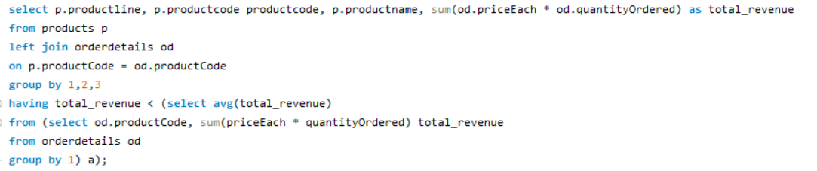

|  |  |  |  |
| --- | --- | --- | --- |
| Product Line | Product Code | ProductName | Total Revenue |
| Classic Cars | S12_3990 | 1970 Plymouth Hemi Cuda | 63489.95 |
| Vintage Cars | S18_1367 | 1936 Mercedes-Benz 500K Special Roadster | 46078.29 |
| Classic Cars | S18_1889 | 1948 Porsche 356-A Roadster | 66455.62 |
| Vintage Cars | S18_2248 | 1911 Ford Town Car | 45306.77 |
| Trucks and Buses | S18_2432 | 1926 Ford Fire Engine | 55835.3 |
| Planes | S18_2581 | P-51-D Mustang | 68741.91 |
| Motorcycles | S18_2625 | 1936 Harley Davidson El Knucklehead | 49992.72 |
| Vintage Cars | S18_2957 | 1934 Ford V8 Coupe | 55172.21 |
| Ships | S18_3029 | 1999 Yamaha Speed Boat | 74127.24 |
| Vintage Cars | S18_3136 | 18th Century Vintage Horse Carriage | 85328.57 |
| Trains | S18_3259 | Collectable Wooden Train | 82617.12 |
| Classic Cars | S18_3278 | 1969 Dodge Super Bee | 68783.93 |
| Vintage Cars | S18_3320 | 1917 Maxwell Touring Car | 87637.63 |
| Motorcycles | S18_3782 | 1957 Vespa GS150 | 54024.87 |
| Vintage Cars | S18_4409 | 1932 Alfa Romeo 8C2300 Spider Sport | 71526.22 |
| Vintage Cars | S18_4522 | 1904 Buick Runabout | 77800.54 |
| Vintage Cars | S18_4668 | 1939 Cadillac Limousine | 44037.84 |
| Classic Cars | S18_4933 | 1957 Ford Thunderbird | 50101.57 |
| Classic Cars | S24_1046 | 1970 Chevy Chevelle SS 454 | 53236.67 |
| Classic Cars | S24_1444 | 1970 Dodge Coronet | 50255.45 |
| Classic Cars | S24_1628 | 1966 Shelby Cobra 427 S/C | 42015.54 |
| Vintage Cars | S24_1937 | 1939 Chevrolet Deluxe Coupe | 28052.94 |
| Motorcycles | S24_2000 | 1960 BSA Gold Star DBD34 | 67193.49 |
| Vintage Cars | S24_2022 | 1938 Cadillac V-16 Presidential Limousine | 38449.09 |
| Motorcycles | S24_2360 | 1982 Ducati 900 Monster | 57995.25 |
| Classic Cars | S24_2766 | 1949 Jaguar XK 120 | 76670.02 |
| Classic Cars | S24_2840 | 1958 Chevy Corvette Limited Edition | 31627.96 |
| Planes | S24_2841 | 1900s Vintage Bi-Plane | 58434.07 |
| Classic Cars | S24_2972 | 1982 Lamborghini Diablo | 30972.87 |
| Vintage Cars | S24_3151 | 1912 Ford Model T Delivery Wagon | 77239.92 |
| Classic Cars | S24_3191 | 1969 Chevrolet Camaro Z28 | 67357.3 |
| Classic Cars | S24_3371 | 1971 Alpine Renault 1600s | 52339.53 |
| Vintage Cars | S24_3420 | 1937 Horch 930V Limousine | 52803.75 |
| Classic Cars | S24_3432 | 2002 Chevy Corvette | 87404.81 |
| Vintage Cars | S24_3816 | 1940 Ford Delivery Sedan | 71208.18 |
| Planes | S24_3949 | Corsair F4U ( Bird Cage) | 62269.67 |
| Vintage Cars | S24_3969 | 1936 Mercedes Benz 500k Roadster | 29763.39 |
| Planes | S24_4278 | 1900s Vintage Tri-Plane | 68276.35 |
| Classic Cars | S24_4620 | 1961 Chevrolet Impala | 69120.97 |
| Trucks and Buses | S32_1268 | 1980â€™s GM Manhattan Express | 78067.82 |
| Motorcycles | S32_2206 | 1982 Ducati 996 R | 33268.76 |
| Trucks and Buses | S32_2509 | 1954 Greyhound Scenicruiser | 46519.05 |
| Trains | S32_3207 | 1950's Chicago Surface Lines Streetcar | 53791.99 |
| Trucks and Buses | S32_3522 | 1996 Peterbilt 379 Stake Bed with Outrigger | 57282.49 |
| Vintage Cars | S32_4289 | 1928 Ford Phaeton Deluxe | 60493.33 |
| Motorcycles | S32_4485 | 1974 Ducati 350 Mk3 Desmo | 84039.24 |
| Vintage Cars | S50_1341 | 1930 Buick Marquette Phaeton | 41599.24 |
| Trains | S50_1514 | 1962 City of Detroit Streetcar | 52123.81 |
| Motorcycles | S50_4713 | 2002 Yamaha YZR M1 | 73670.64 |
| Ships | S700_1138 | The Schooner Bluenose | 56455.11 |
| Planes | S700_1691 | American Airlines: B767-300 | 73871.22 |
| Ships | S700_1938 | The Mayflower | 69531.61 |
| Ships | S700_2047 | HMS Bounty | 73298.42 |
| Ships | S700_2610 | The USS Constitution Ship | 66697.13 |
| Planes | S700_3167 | F/A 18 Hornet 1/72 | 76618.4 |
| Ships | S700_3505 | The Titanic | 84992.25 |
| Ships | S700_3962 | The Queen Mary | 78919.06 |
| Planes | S700_4002 | American Airlines: MD-11S | 71753.93 |
| Planes | S72_1253 | Boeing X-32A JSF | 42692.53 |
| Ships | S72_3212 | Pont Yacht | 47550.4 |

**Insight:   
  
A critical observation reveals that the following products are underperforming, as the cumulative revenue from these products falls short of the average revenue earned across all products.**A thorough analysis indicates that certain products are experiencing subpar performance, as the combined revenue generated by these specific products does not meet the established average revenue earned across the entire product range. This observation underscores the need for further examination and potential strategic adjustments to enhance the performance of these underperforming products

What are the main factors that influence customer loyalty and repeat purchases?

**Insight: Customer loyalty and repeat purchases are influenced by:**

1. Product/Service Quality

2. Customer Service  
3. Brand Trust

4. Discount

5. Competitive Pricing

6. Feedback and Improvement

7. Loyalty Incentives

**Focusing on these factors improves loyalty and encourages repeat purchases.**

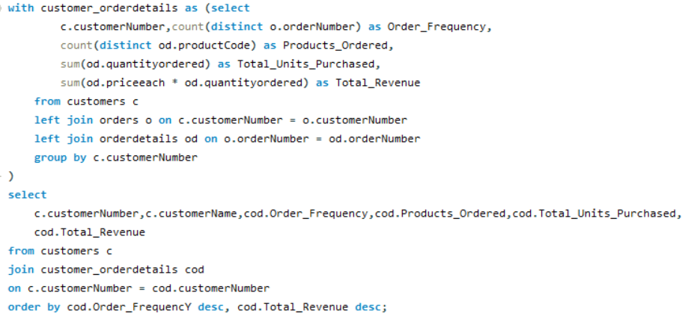

|  |  |  |  |  |  |
| --- | --- | --- | --- | --- | --- |
| customer Number | customer Name | Order Frequency | Products_Ordered | Total_Units_Purchased | Total Revenue |
| 141 | Euro+ Shopping Channel | 26 | 106 | 9327 | 820689.54 |
| 124 | Mini Gifts Distributors Ltd. | 17 | 77 | 6366 | 591827.34 |
| 114 | Australian Collectors, Co. | 5 | 40 | 1926 | 180585.07 |
| 148 | Dragon Souveniers, Ltd. | 5 | 37 | 1524 | 156251.03 |
| 323 | Down Under Souveniers, Inc | 5 | 42 | 1691 | 154622.08 |
| 145 | Danish Wholesale Imports | 5 | 31 | 1315 | 129085.12 |
| 353 | Reims Collectables | 5 | 37 | 1433 | 126983.19 |
| 151 | Muscle Machine Inc | 4 | 32 | 1775 | 177913.95 |
| 119 | La Rochelle Gifts | 4 | 43 | 1832 | 158573.12 |
| 131 | Land of Toys Inc. | 4 | 41 | 1631 | 149085.15 |
| 450 | The Sharp Gifts Warehouse | 4 | 39 | 1656 | 143536.27 |
| 382 | Salzburg Collectables | 4 | 36 | 1442 | 137480.07 |
| 496 | Kelly's Gift Shop | 4 | 45 | 1647 | 137460.79 |
| 276 | Anna's Decorations, Ltd | 4 | 41 | 1469 | 137034.22 |
| 282 | Souveniers And Things Co. | 4 | 44 | 1601 | 133907.12 |
| 321 | Corporate Gift Ideas Co. | 4 | 40 | 1447 | 132340.78 |
| 166 | Handji Gifts& Co | 4 | 29 | 1236 | 107746.75 |
| 398 | Tokyo Collectables, Ltd | 4 | 32 | 1150 | 105548.73 |
| 161 | Technics Stores Inc. | 4 | 30 | 1179 | 104545.22 |
| 157 | Diecast Classics Inc. | 4 | 31 | 1111 | 104358.69 |
| 121 | Baane Mini Imports | 4 | 32 | 1082 | 104224.79 |
| 128 | Blauer See Auto, Co. | 4 | 22 | 811 | 75937.76 |
| 144 | Volvo Model Replicas, Co | 4 | 19 | 647 | 66694.82 |
| 381 | Royale Belge | 4 | 8 | 278 | 29217.18 |
| 187 | AV Stores, Co. | 3 | 37 | 1778 | 148410.09 |
| 146 | Saveley & Henriot, Co. | 3 | 41 | 1428 | 130305.35 |
| 278 | Rovelli Gifts | 3 | 34 | 1650 | 127529.69 |
| 386 | L'ordine Souveniers | 3 | 39 | 1280 | 125505.57 |
| 448 | Scandinavian Gift Ideas | 3 | 38 | 1359 | 120943.53 |
| 363 | Online Diecast Creations Co. | 3 | 34 | 1248 | 116449.29 |
| 458 | Corrida Auto Replicas, Ltd | 3 | 26 | 1163 | 112440.09 |
| 201 | UK Collectables, Ltd. | 3 | 29 | 1046 | 106610.72 |
| 334 | Suominen Souveniers | 3 | 30 | 1031 | 103896.74 |
| 320 | Mini Creations Ltd. | 3 | 34 | 1140 | 101872.52 |
| 167 | Herkku Gifts | 3 | 29 | 973 | 97562.47 |
| 311 | Oulu Toy Supplies, Inc. | 3 | 31 | 1110 | 95706.15 |
| 186 | Toys of Finland, Co. | 3 | 30 | 1051 | 95546.46 |
| 175 | Gift Depot Inc. | 3 | 25 | 903 | 95424.63 |
| 357 | GiftsForHim.com | 3 | 26 | 1003 | 94431.76 |
| 205 | Toys4GrownUps.com | 3 | 29 | 1060 | 93803.3 |
| 412 | Extreme Desk Decorations, Ltd | 3 | 29 | 1055 | 90332.38 |
| 462 | FunGiftIdeas.com | 3 | 26 | 903 | 88627.49 |
| 385 | Cruz & Sons Co. | 3 | 22 | 961 | 87468.3 |
| 172 | La Corne D'abondance, Co. | 3 | 22 | 836 | 86553.52 |
| 406 | Auto Canal+ Petit | 3 | 18 | 1001 | 86436.97 |
| 362 | Gifts4AllAges.com | 3 | 21 | 1036 | 84340.32 |
| 328 | Tekni Collectables Inc. | 3 | 21 | 988 | 81806.55 |
| 324 | Stylish Desk Decors, Co. | 3 | 26 | 937 | 80556.73 |
| 112 | Signal Gift Stores | 3 | 24 | 929 | 80180.98 |
| 486 | Motor Mint Distributors Inc. | 3 | 17 | 730 | 77726.59 |
| 209 | Mini Caravy | 3 | 19 | 779 | 75859.32 |
| 379 | Collectables For Less Inc. | 3 | 24 | 795 | 73533.65 |
| 181 | Vitachrome Inc. | 3 | 25 | 787 | 72497.64 |
| 350 | Marseille Mini Autos | 3 | 24 | 804 | 71547.53 |
| 314 | Petit Auto | 3 | 20 | 796 | 70851.58 |
| 424 | Classic Legends Inc. | 3 | 20 | 720 | 69214.33 |
| 233 | QuÃ©bec Home Shopping Network | 3 | 22 | 717 | 68977.67 |
| 216 | Enaco Distributors | 3 | 22 | 882 | 68520.47 |
| 250 | Lyon Souveniers | 3 | 20 | 684 | 67659.19 |
| 129 | Mini Wheels Co. | 3 | 19 | 692 | 66710.56 |
| 242 | Alpha Cognac | 3 | 20 | 687 | 60483.36 |
| 471 | Australian Collectables, Ltd | 3 | 23 | 705 | 55866.02 |
| 333 | Australian Gift Network, Co | 3 | 15 | 545 | 55190.16 |
| 452 | Mini Auto Werke | 3 | 15 | 532 | 51059.99 |
| 447 | Gift Ideas Corp. | 3 | 19 | 666 | 49967.78 |
| 103 | Atelier graphique | 3 | 7 | 270 | 22314.36 |
| 198 | Auto-Moto Classics Inc. | 3 | 8 | 287 | 21554.26 |
| 298 | Vida Sport, Ltd | 2 | 17 | 1078 | 108777.92 |
| 286 | Marta's Replicas Co. | 2 | 27 | 976 | 90545.37 |
| 227 | Heintze Collectables | 2 | 27 | 882 | 89909.8 |
| 259 | Toms SpezialitÃ¤ten, Ltd | 2 | 17 | 936 | 89223.14 |
| 249 | Amica Models & Co. | 2 | 26 | 843 | 82223.23 |
| 239 | Collectable Mini Designs Co. | 2 | 25 | 954 | 80375.24 |
| 319 | Mini Classics | 2 | 26 | 929 | 78432.16 |
| 240 | giftsbymail.co.uk | 2 | 26 | 895 | 71783.75 |
| 455 | Super Scale Inc. | 2 | 17 | 636 | 70378.65 |
| 202 | Canadian Gift Exchange Network | 2 | 19 | 703 | 70122.19 |
| 299 | Norway Gifts By Mail, Co. | 2 | 24 | 787 | 69059.04 |
| 260 | Royal Canadian Collectables, Ltd. | 2 | 26 | 873 | 66812 |
| 495 | Diecast Collectables | 2 | 18 | 695 | 65541.74 |
| 177 | Osaka Souveniers Co. | 2 | 20 | 692 | 62361.22 |
| 171 | Daedalus Designs Imports | 2 | 14 | 699 | 61781.7 |
| 256 | Auto AssociÃ©s & Cie. | 2 | 17 | 637 | 58876.41 |
| 339 | Classic Gift Ideas, Inc | 2 | 21 | 668 | 57939.34 |
| 204 | Online Mini Collectables | 2 | 15 | 572 | 55577.26 |
| 484 | Iberia Gift Imports, Corp. | 2 | 15 | 589 | 50987.85 |
| 189 | Clover Collections, Co. | 2 | 16 | 490 | 49898.27 |
| 344 | CAF Imports | 2 | 13 | 468 | 46751.14 |
| 211 | King Kong Collectables, Co. | 2 | 12 | 596 | 45480.79 |
| 475 | West Coast Collectables Co. | 2 | 13 | 511 | 43748.72 |
| 487 | Signal Collectibles Ltd. | 2 | 15 | 514 | 42570.37 |
| 347 | Men 'R' US Retailers, Ltd. | 2 | 14 | 500 | 41506.19 |
| 173 | Cambridge Collectables Co. | 2 | 11 | 357 | 32198.69 |
| 489 | Double Decker Gift Stores, Ltd | 2 | 12 | 357 | 29586.15 |
| 456 | Microscale Inc. | 2 | 10 | 381 | 29230.43 |
| 473 | Frau da Collezione | 2 | 8 | 272 | 25358.32 |
| 219 | Boards & Toys Co. | 2 | 3 | 102 | 7918.6 |
| 415 | Bavarian Collectables Imports, Co. | 1 | 14 | 401 | 31310.09 |
| 125 | Havel & Zbyszek Co | 0 | 0 |  |  |
| 168 | American Souvenirs Inc | 0 | 0 |  |  |
| 169 | Porto Imports Co. | 0 | 0 |  |  |
| 206 | Asian Shopping Network, Co | 0 | 0 |  |  |
| 223 | NatÃ¼rlich Autos | 0 | 0 |  |  |
| 237 | ANG Resellers | 0 | 0 |  |  |
| 247 | Messner Shopping Network | 0 | 0 |  |  |
| 273 | Franken Gifts, Co | 0 | 0 |  |  |
| 293 | BG&E Collectables | 0 | 0 |  |  |
| 303 | Schuyler Imports | 0 | 0 |  |  |
| 307 | Der Hund Imports | 0 | 0 |  |  |
| 335 | Cramer SpezialitÃ¤ten, Ltd | 0 | 0 |  |  |
| 348 | Asian Treasures, Inc. | 0 | 0 |  |  |
| 356 | SAR Distributors, Co | 0 | 0 |  |  |
| 361 | Kommission Auto | 0 | 0 |  |  |
| 369 | Lisboa Souveniers, Inc | 0 | 0 |  |  |
| 376 | Precious Collectables | 0 | 0 |  |  |
| 409 | Stuttgart Collectable Exchange | 0 | 0 |  |  |
| 443 | Feuer Online Stores, Inc | 0 | 0 |  |  |
| 459 | Warburg Exchange | 0 | 0 |  |  |
| 465 | Anton Designs, Ltd. | 0 | 0 |  |  |
| 477 | Mit VergnÃ¼gen & Co. | 0 | 0 |  |  |
| 480 | Kremlin Collectables, Co. | 0 | 0 |  |  |
| 481 | Raanan Stores, Inc | 0 | 0 |  |  |

**Insight: Customer loyalty and repeat purchases are influenced by:**

1. Product/Service Quality

2. Customer Service  
3. Brand Trust

4. Discount

5. Competitive Pricing

6. Feedback and Improvement

7. Loyalty Incentives

**Focusing on these factors improves loyalty and encourages repeat purchases.**

How do customer preferences differ based on geographic location, and how can marketing campaigns be customized accordingly?

**Insight:   
  
Customer preferences can vary significantly based on geographic location due to cultural, economic, and environmental factors. To customize marketing campaigns effectively, businesses should consider the following:**

1. Language  
2. Climate and Seasonal Variation  
3. Economic Factors  
4. Local Trends and Traditions  
5. Legal and Regulatory Compliance  
6. Local Competition  
7. Market Research  
8. Customer Feedback

**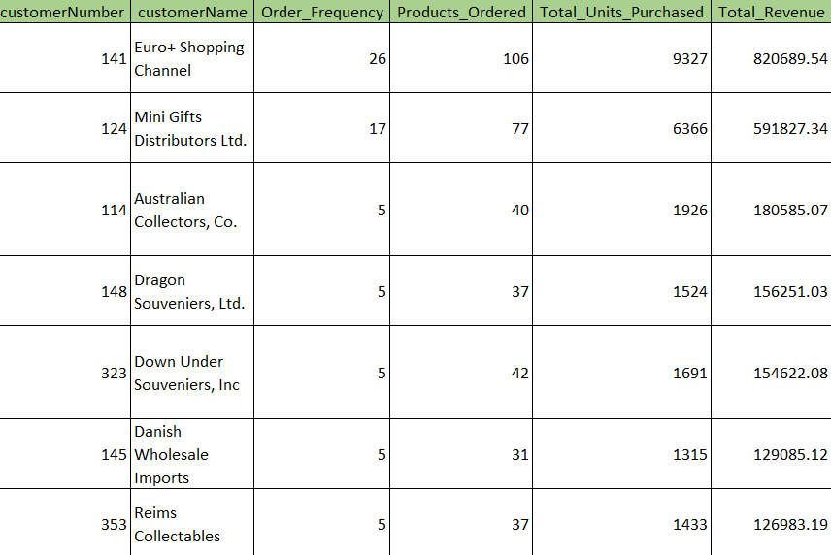  
  
  
  
  
  
  
  
  
  
  
  
  
  
  
  
  
  
  
  
  
  
  
  
  
  
  
  
  
  
  
  
  
  
  
  
  
  
  
  
  
  
  
  
  
  
  
  
  
  
  
  
  
  
  
  
  
  
  
  
  
  
  
  
  
  
  
  
  
  
  
  
  
  
  
  
  
  
  
  
  
  
  
  
  
  
  
  
  
  
  
  
  
  
  
  
  
  
  
  
  
  
  
  
  
  
  
  
  
  
  
  
  
  
  
  
  
  
  
  
  
  
  
  
  
  
  
  
  
  
  
  
  
  
  
  
  
  
  
  
  
  
  
  
  
  
  
  
  
  
  
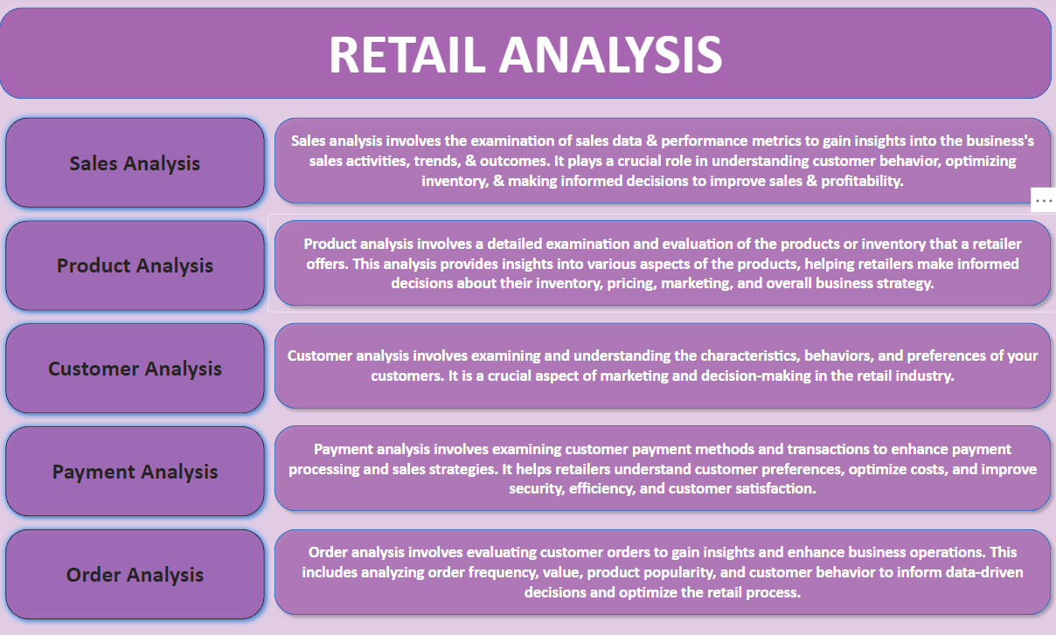  
  
  
  
  
  
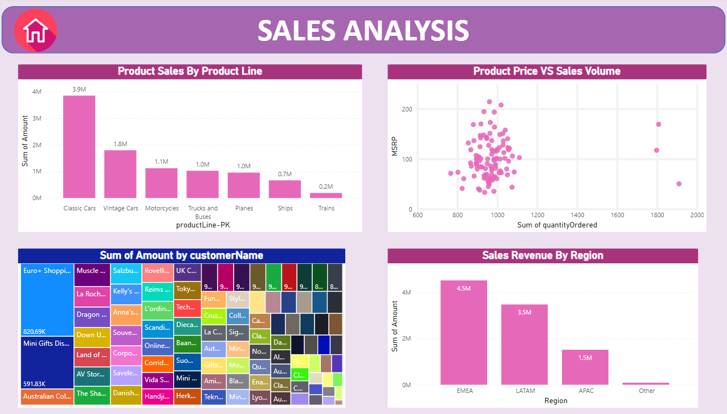  
  
  
  
  
  
  
  
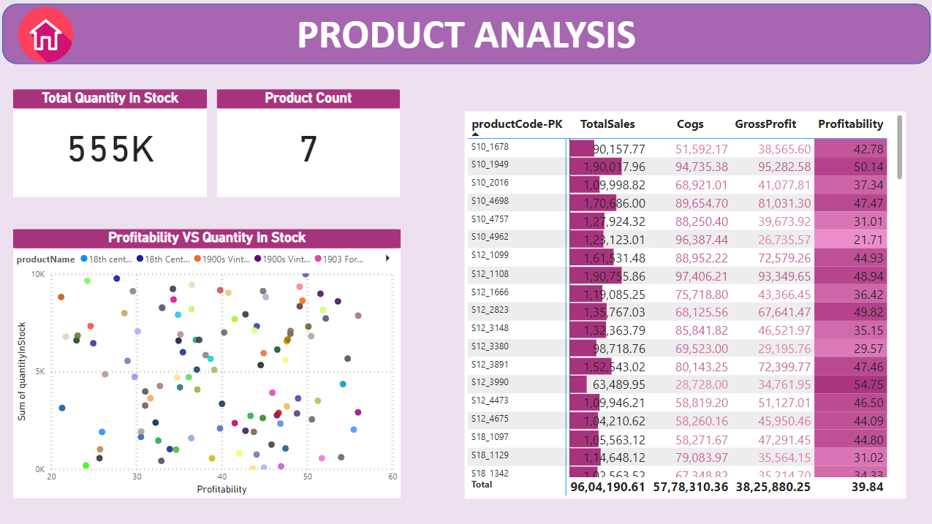  
  
  
  
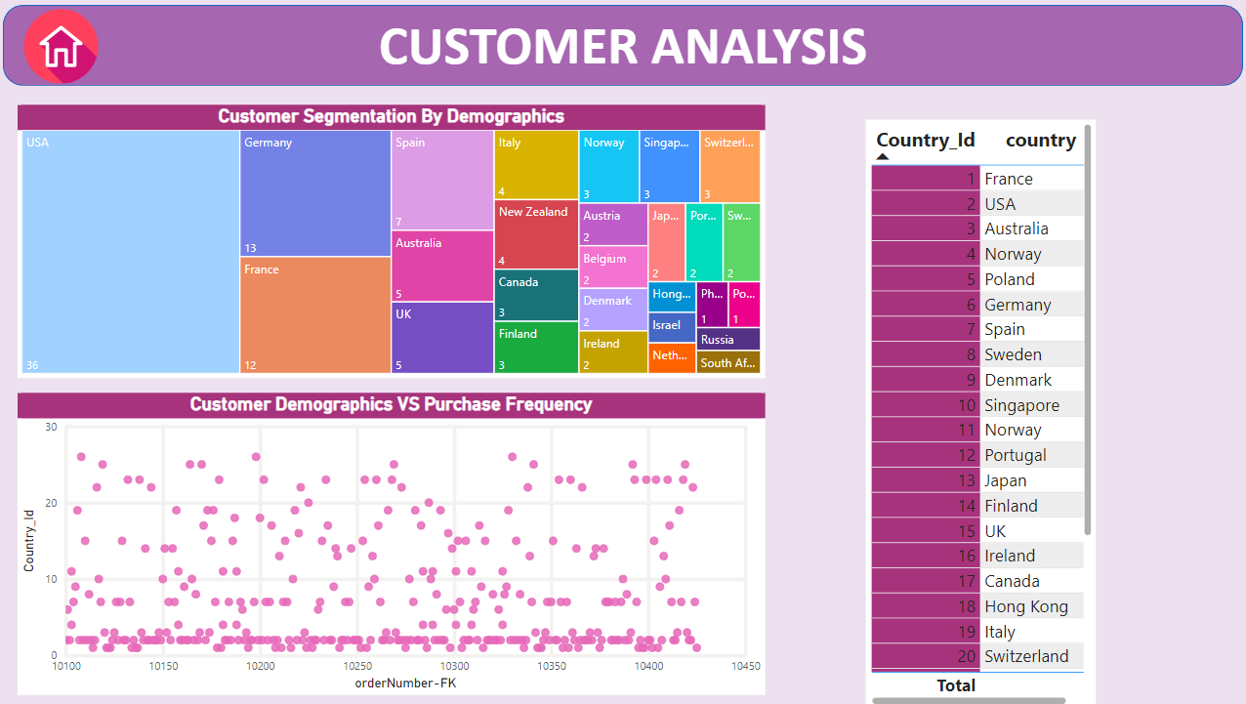  
  
  
  
  
  
  
  
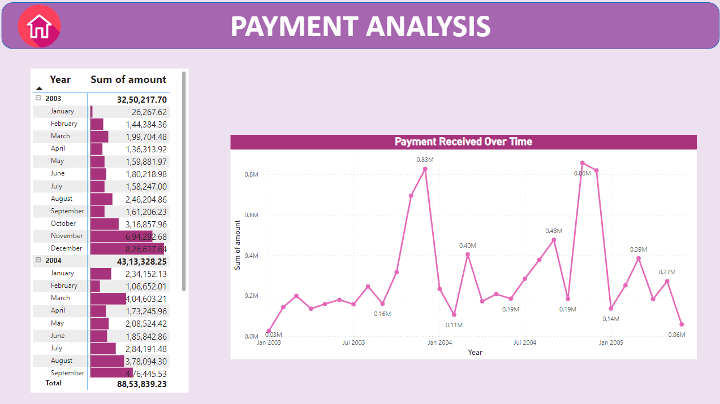  
  
  
  
  
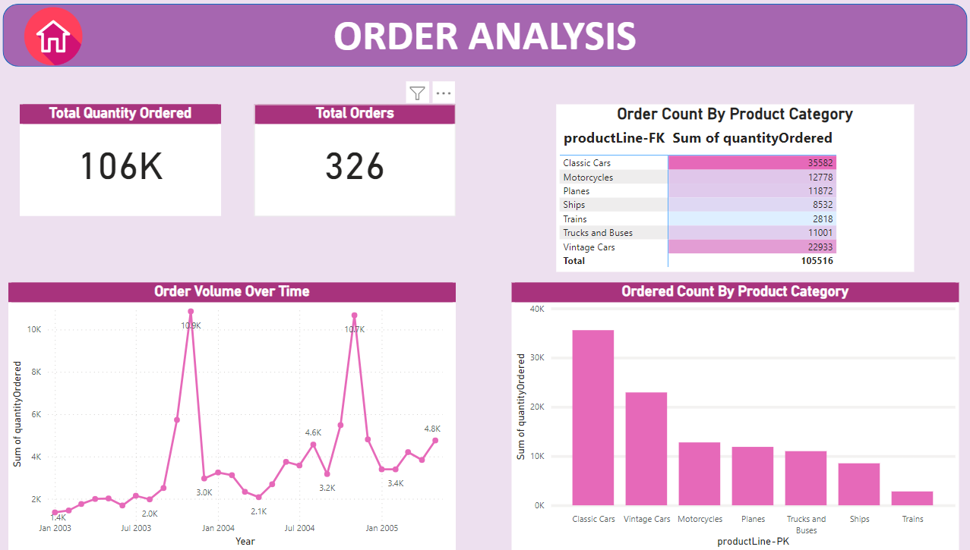  
  
  
  
  
  
  
  
  
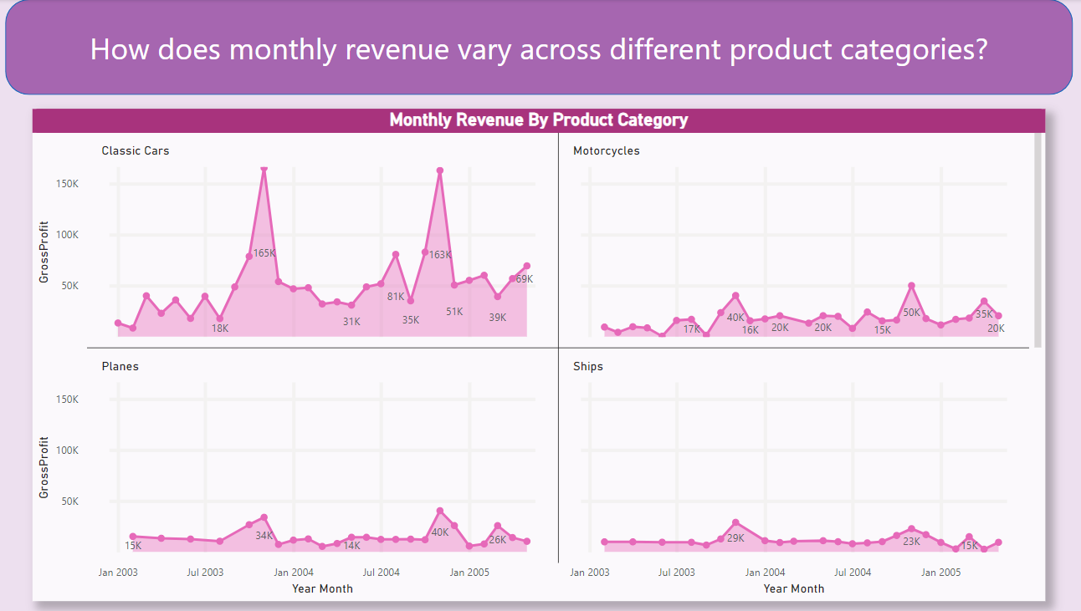  
  
  
  
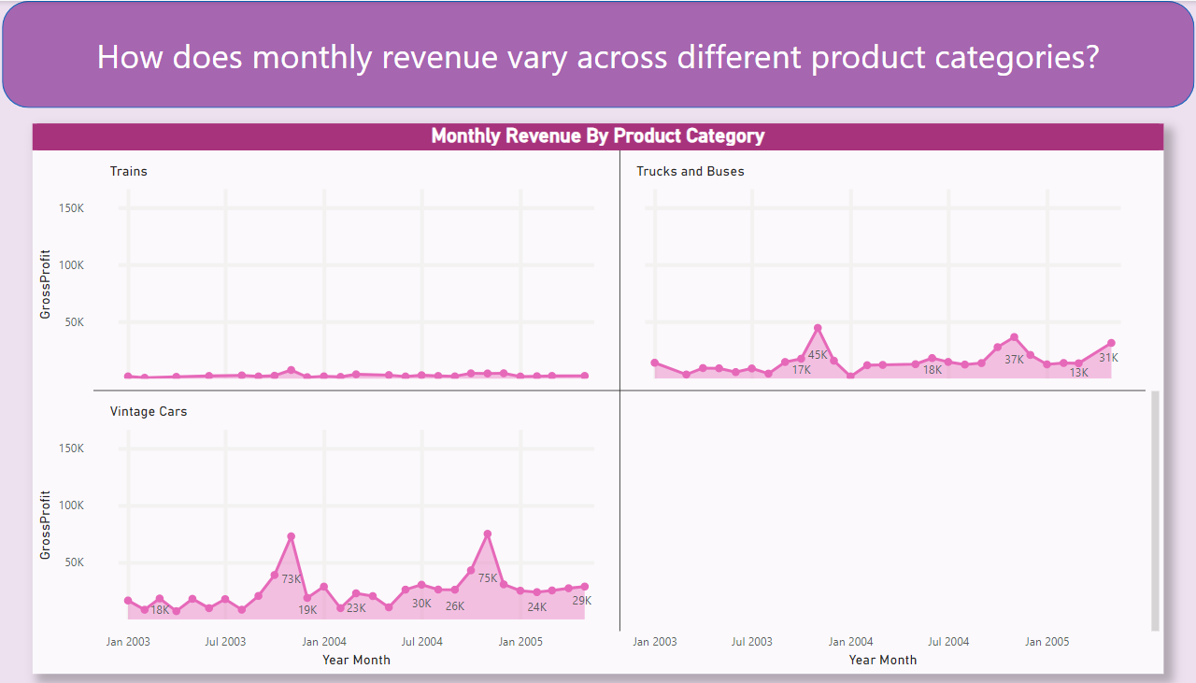  
  
  
  
  
  
  
  
  
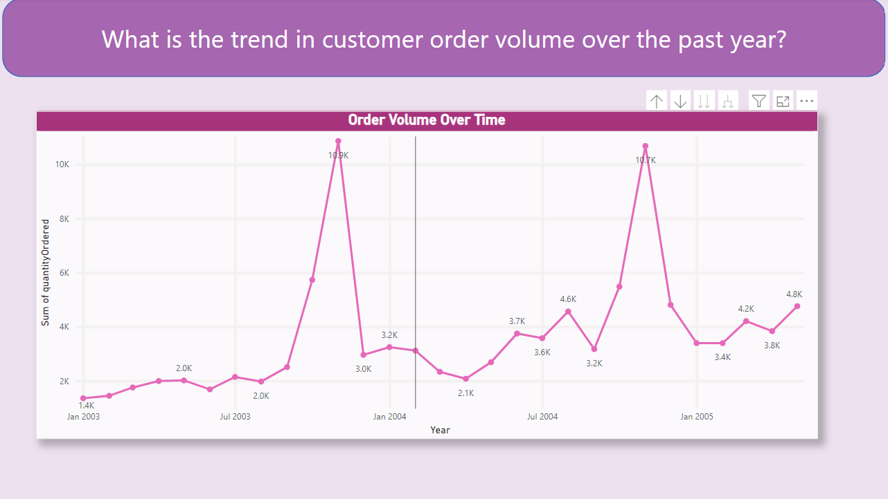  
  
  
  
  
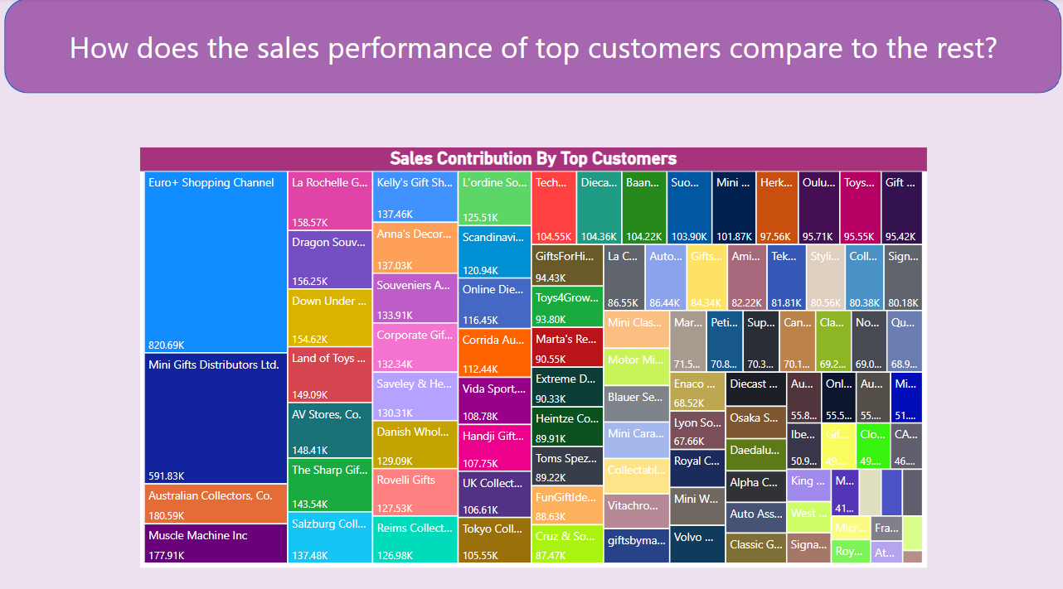  
  
  
  
  
  
  
  
  
  
  
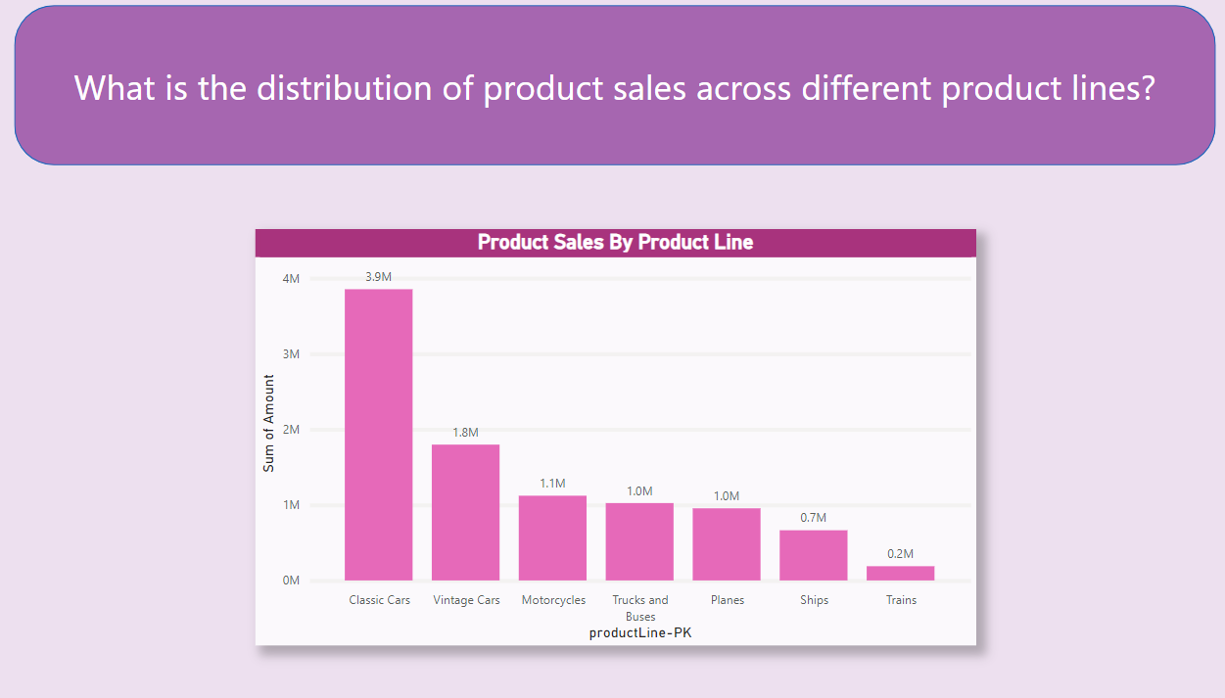  
  
  
  
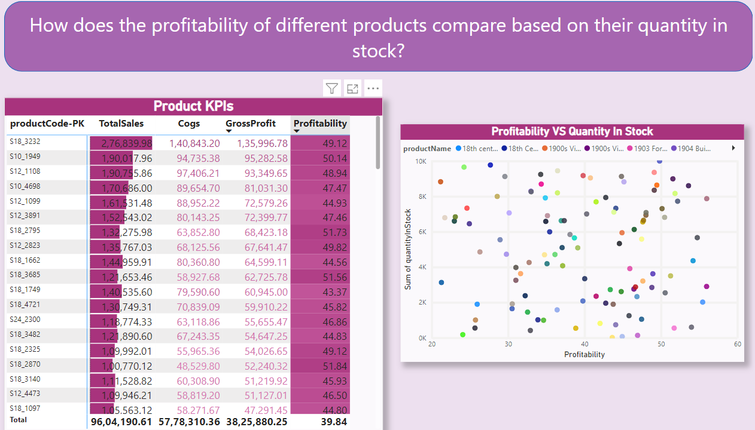  
  
  
  
  
  
  
  
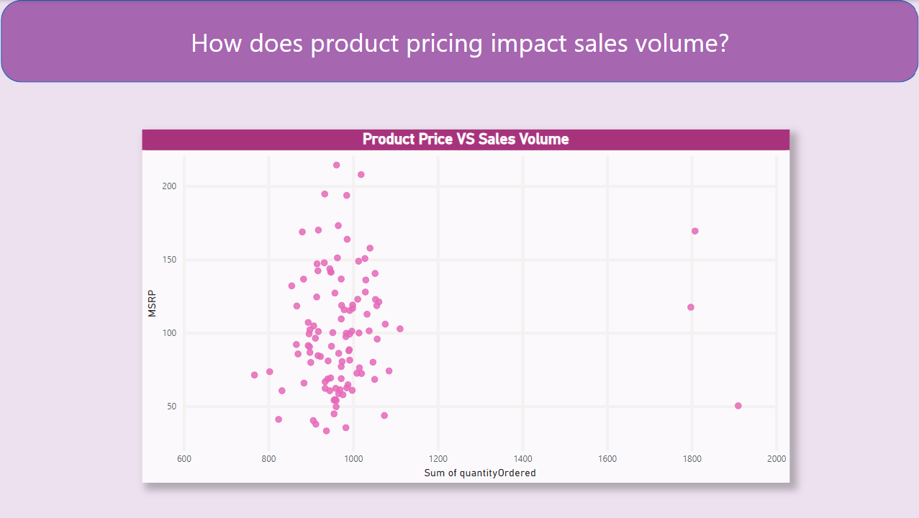  
  
  
  
  
  
  
  
  
  
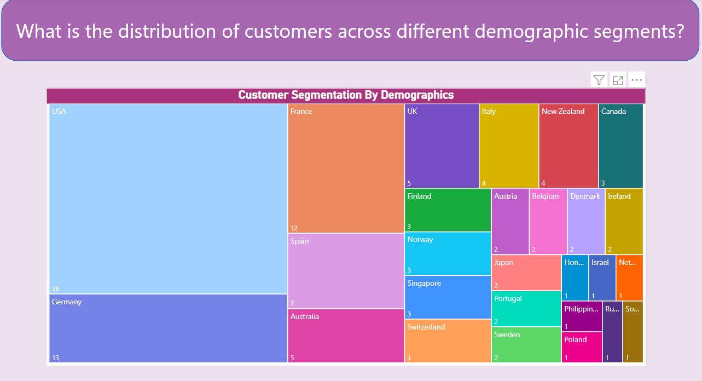  
  
  
  
  
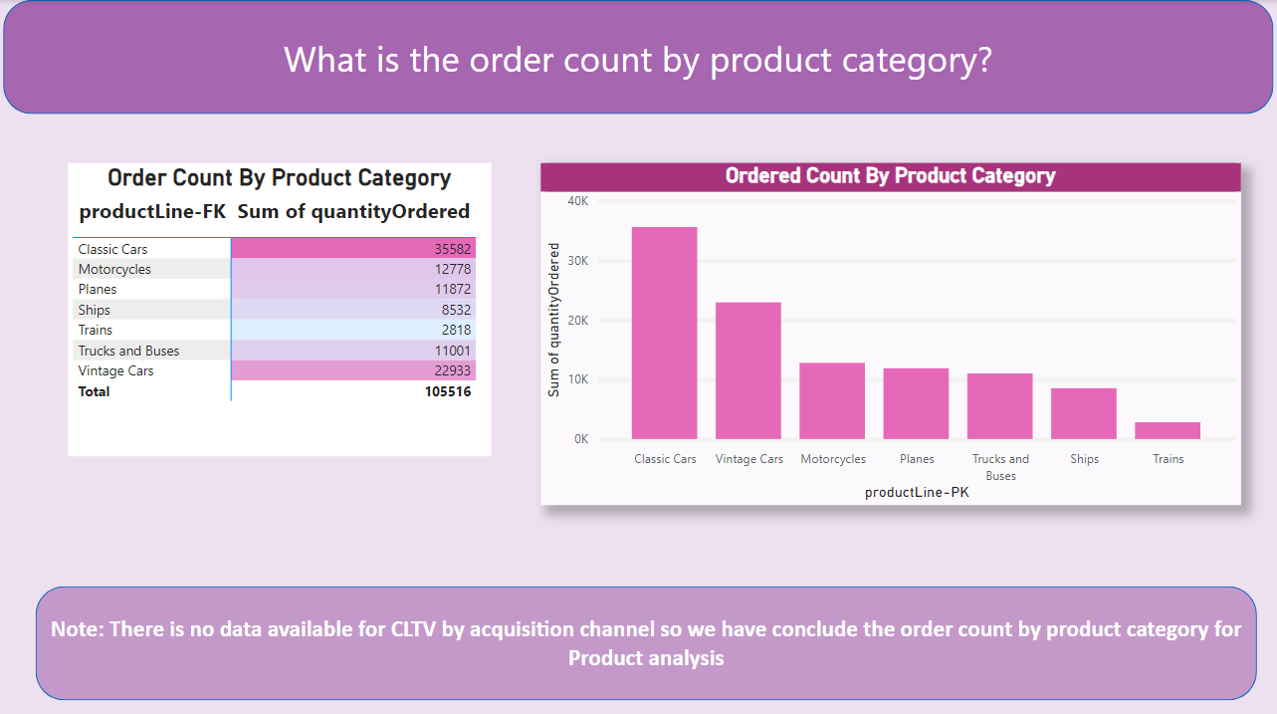  
  
  
  
  
  
  
  
  
  
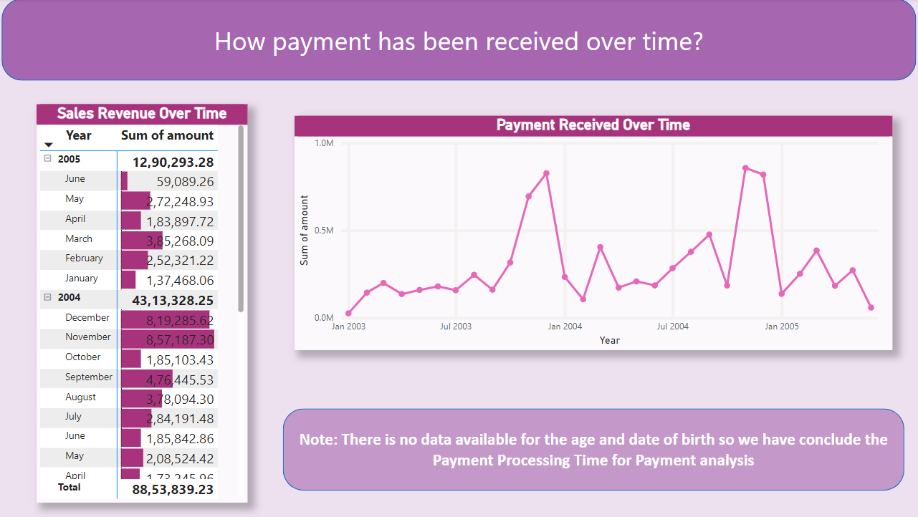  
  
  
  
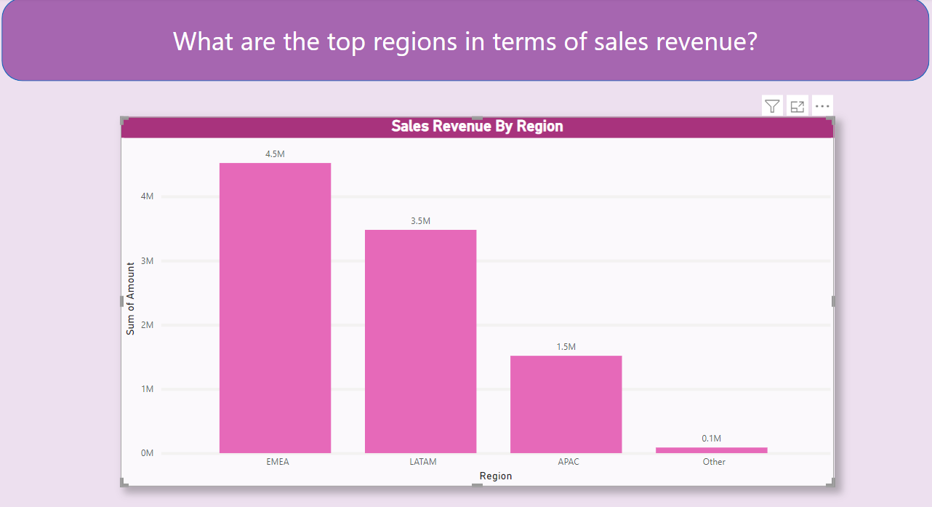  
  
  
  
  
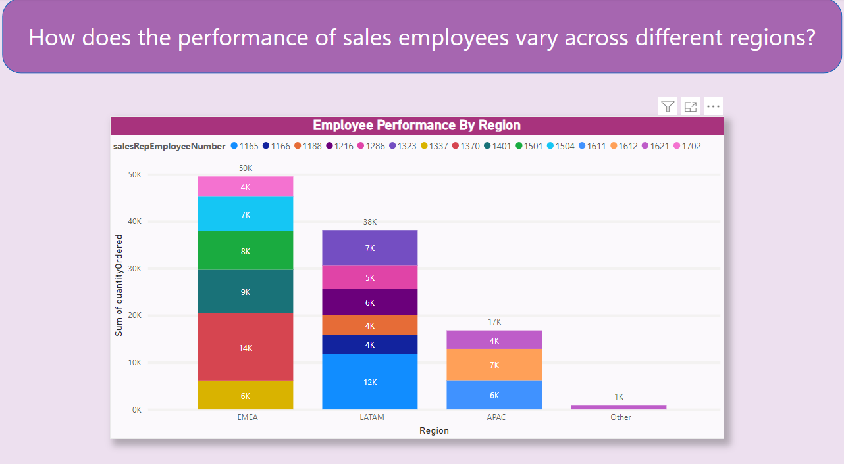  
  
  
  
  
  
  
  
  
  
  
  
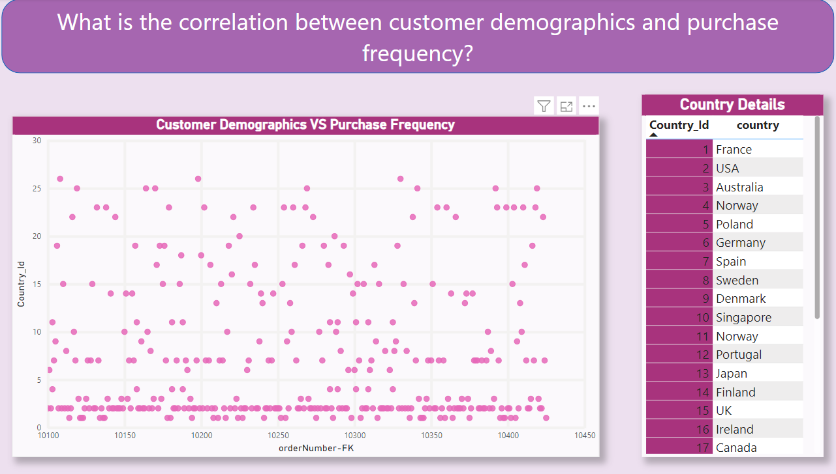**

**Insight:   
  
Customer preferences can vary significantly based on geographic location due to cultural, economic, and environmental factors. To customize marketing campaigns effectively, businesses should consider the following:**

1. Language  
2. Climate and Seasonal Variation  
3. Economic Factors  
4. Local Trends and Traditions  
5. Legal and Regulatory Compliance  
6. Local Competition  
7. Market Research  
8. Customer Feedback

**Insight:**

**Characteristics of High-Value Customers:**

1. High Spending

2. Loyalty

3. Long-term Engagement  
4. Profitability

5. Advocacy  
  
**Targeting Similar Customers for Acquisition:**

1. Data Analysis  
2. Customer Segmentation  
3. Look-alike Modelling  
4. Personalized Marketing  
5. Referral Programs

6. Improve Customer Experience

7. Cross-selling and Upselling

8. Retention Strategies

9. A/B Testing

What are the characteristics of high-value customers, and how can similar customers be targeted for acquisition?

**Insight:**

**Characteristics of High-Value Customers:**

1. High Spending

2. Loyalty

3. Long-term Engagement  
4. Profitability

5. Advocacy  
  
**Targeting Similar Customers for Acquisition:**

1. Data Analysis  
2. Customer Segmentation  
3. Look-alike Modelling  
4. Personalized Marketing  
5. Referral Programs

6. Improve Customer Experience

7. Cross-selling and Upselling

8. Retention Strategies

9. A/B Testing

How can marketing strategies be tailored to target specific demographic segments in different regions?

**Insight:**  
  
Tailoring marketing strategies to target specific demographic segments in different regions involves a combination of **Market Research, Customer Segmentation, Offer Customization, Testing and Optimization, Local Partnerships and Influencers, Monitor and Measure**

What are the potential untapped markets based on demographic indicators, and how can market penetration be increased?

**To increase market penetration in these untapped markets:**

1. Market Research

2. Product/Service Customization

3. Local Partnerships  
4. Localized Marketing  
5. Pricing and Promotions  
6. Distribution Channels

7. Education and Awareness

8. Customer Feedback  
9. Continuous Evaluation

**Identifying potential untapped markets based on demographic indicators can be a strategic growth opportunity. Some demographic indicators are:**

1. Age Groups

2. Geographic Areas

3. Cultural Background  
4. Family Status  
5. Income Levels  
6. Gender  
7. Education Level  
8. Digital Adoption

How do customer preferences and behaviour differ based on demographic factors, and how can they be leveraged for personalized marketing campaigns?

**To leverage these differences for personalized marketing:**

1. Conduct thorough market research to understand the preferences of various demographic groups.

2. Segment your customer base by demographics to tailor your marketing campaigns.

3. Use data analytics to track and analyse customer behaviour, enabling dynamic personalization.

4. Craft tailored marketing messages, offers, and content that resonate with each demographic.

5. Implement A/B testing to refine your campaigns based on what works best for each group.

**Conclusion**

This Retail Analysis project aims to provide a holistic view of our retail business, enabling us to make data-driven decisions and improvements in sales, product offerings, customer engagement, payment processing, and order fulfillment. By focusing on these key areas, we can enhance our performance, better serve our customers, and stay competitive in the retail industry.